**Name:** Vineel Sai

**Reg No:** 498

**IIIT Kalyani, Assignment 3 8085 Micro controller**

**PROB.1** WRITE ALP THAT WILL ADD N NUMBER OF BYTES STARTING AT 8C01. VALUE OF N IS STORED IN 8C00H. STORE THE RESULT IN 9000H AND IF CARRY PRESENT STORE IT AT 9001H.

4200 21 00 08C LXI H, 8C00H

4203 4E MOV C, M

4204 21 01 08C LXI H, 8C01H

4207 86 LOOP: ADD M

4208 D2 0C 042 JNC SKIP

420B 1C INR E

420C 0D SKIP: DCR C

420D 23 INX H

420E C2 07 042 JNZ LOOP

4211 21 00 090 LXI H, 9000H

4214 77 MOV M, A

4215 23 INX H

4216 73 MOV M, E

4217 AF XRA A

4218 5F MOV E, A

4219 76 HLT

**INPUT OUTPUT**

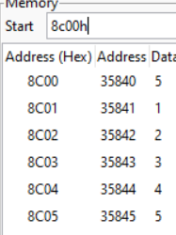 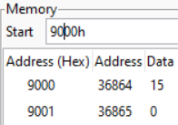

**PROB.2** TWO 8 BIT NUMBERS ARE STORED IN MEMORY LOCATIONS 8C00H AND 8C01H. PERFORM MULTIPLICATION AND STORE THE RESULT IN 8C02H.

4200 21 00 08C LXI H, 8C00H

4203 4E MOV C, M

4204 21 01 08C LXI H, 8C01H

4207 86 LOOP: ADD M

4208 D2 0C 042 JNC SKIP

420B 1C INR E

420C 0D SKIP: DCR C

420D C2 07 042 JNZ LOOP

4210 21 02 08C LXI H, 8C02H

4213 77 MOV M, A

4214 23 INX H

4215 73 MOV M, E

4216 AF XRA A

4217 5F MOV E, A

4218 76 HLT

**OUTPUT**

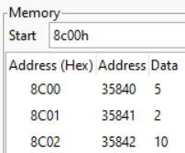

**PROB.3** WRITE AN ALP TO FIND THE SQUARE OF A GIVEN NUMBER STORED IN 8550H, AND STORE THE RESULT IN 8551H.

4200 21 50 85 LXI H, 8C00H

4203 4E MOV C, M

4204 21 50 85 LXI H, 8C00H

4207 86 LOOP: ADD M

4208 D2 0C 042 JNC SKIP

420B 1C INR E

420C 0D SKIP: DCR C

420D C2 07 042 JNZ LOOP

4210 21 51 85 LXI H, 8C01H

4213 77 MOV M, A

4214 23 INX H

4215 73 MOV M, E

4216 AF XRA A

4217 5F MOV E, A

4218 76 HLT

**OUTPUT**

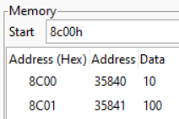

**PROB.4** FIND THE FACTORIAL OF A GIVEN NUMBER XX, STORED IN 8C00H, AND STORE THE RESULT IN 8C01H.

4200 21 00 08C LXI H, 8C00H

4203 4E MOV C, M

4204 21 00 08C LXI H, 8C00H

4207 0D DCR C

4208 86 LOOP: ADD M

4209 0D DCR C

420A C2 08 042 JNZ LOOP

420D 21 01 08C LXI H, 8C01H

4210 77 MOV M, A

4211 AF XRA A

4212 5F MOV E, A

4213 76 HLT

**OUTPUT**

